**RESULTS**

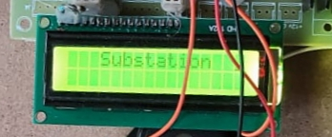

**FIG-1:** Switch on the kit

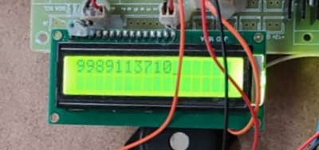

**FIG-2:** Register the contact number

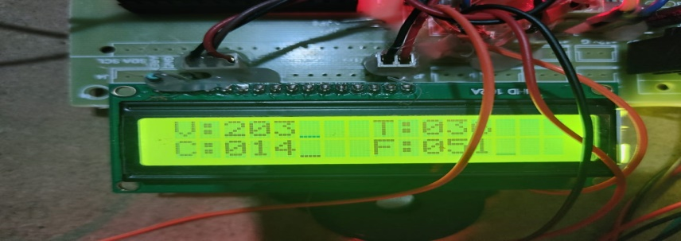

**FIG-.3:** Monitoring all the electrical parameters

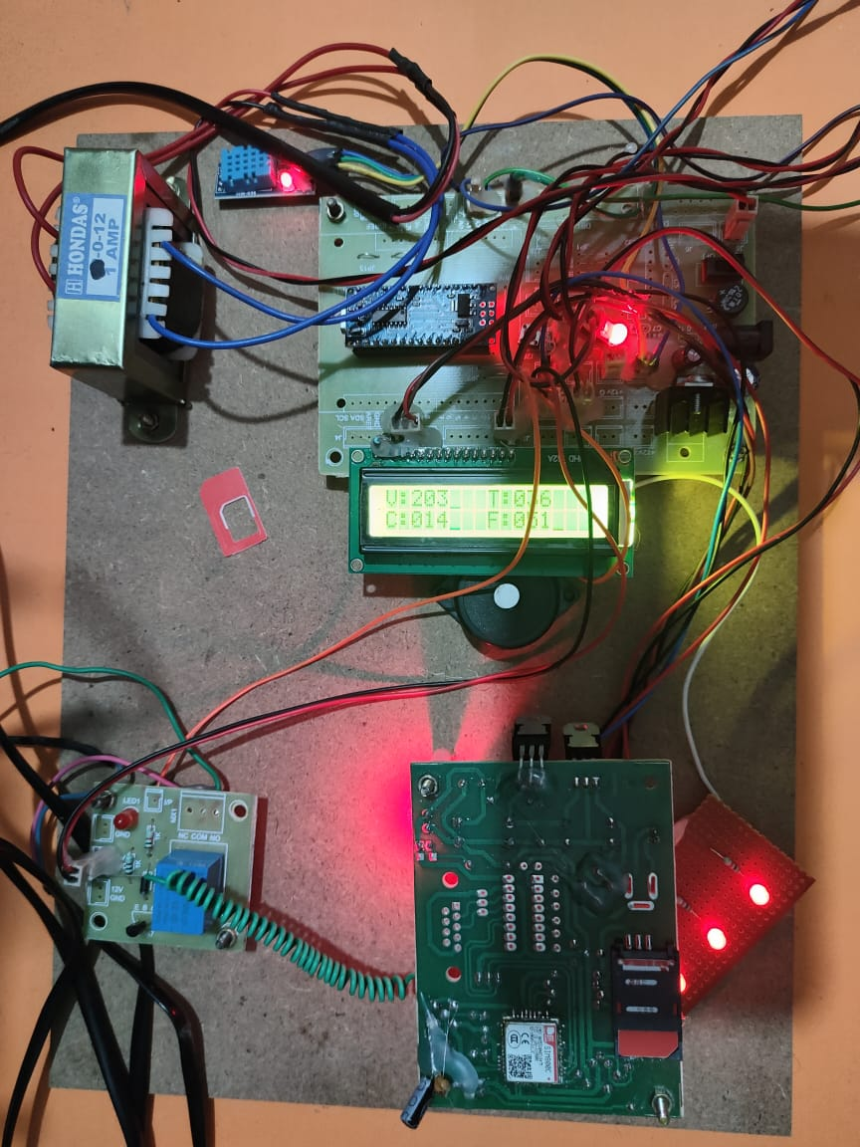

**FIG-.4:** Hardware Implementation

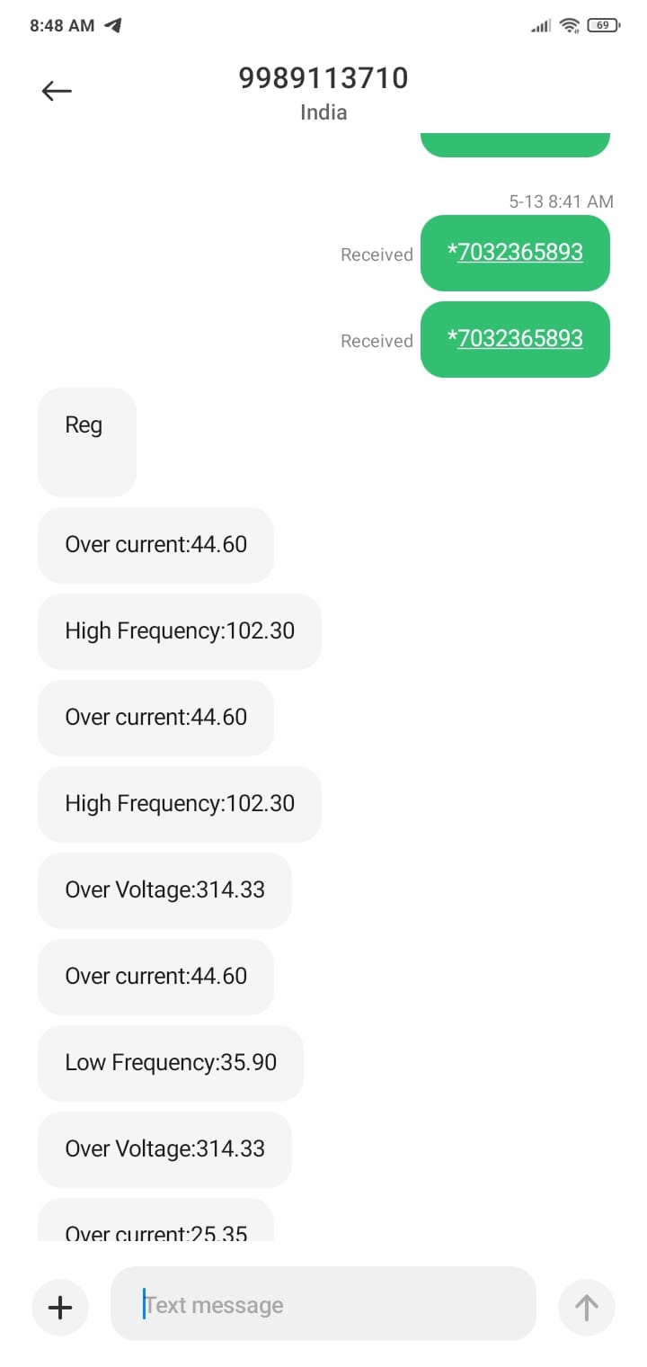

**FIG-5:** Monitoring results through SMS Commands

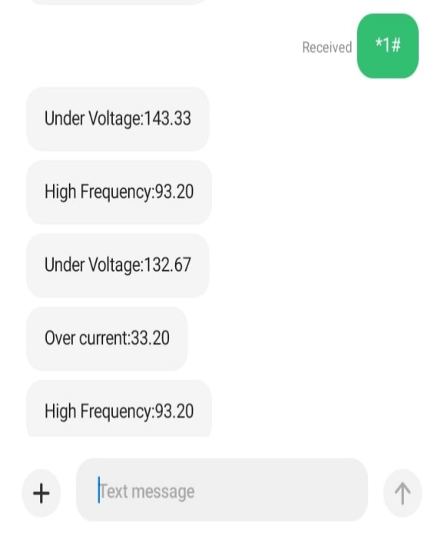

**FIG-6:** Controlling Using Load On

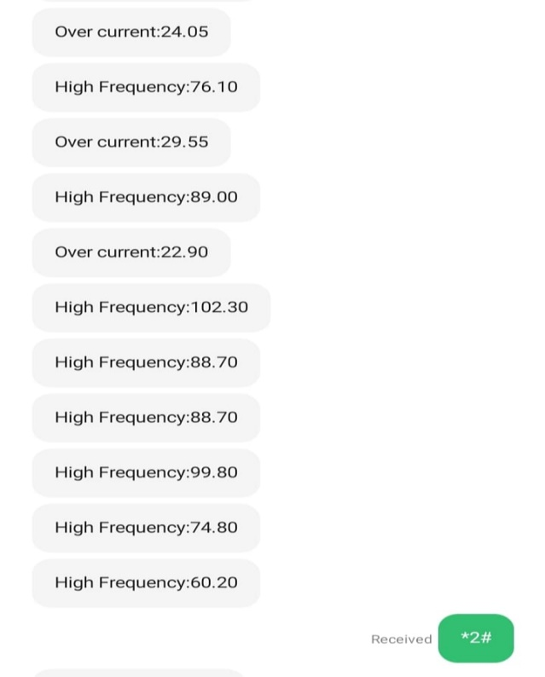

**FIG-7:** Controlling Using Load Off